|  |  |
| --- | --- |
| A picture of a winding road and trees  CCT College Dublin Continuous Assessment  Agricultural Ireland's data Analysis | Abstract  *The agricultural sector can be considered the backbone of each country. Digital Agriculture (DA) spread in the last decade due to applying Information and Communication Technologies (ICT) in agriculture. DA established novel procedures for farming to guarantee crop increment, efficiency, and control while protecting the environment.*  Reham Tousoun  MSC_DA_CA2 |

Word count excluded Titles, Figures, Tables, and references is: **5105** words

Table of Contents

Introduction 4

Assignment Questions: 5

Data Set Used and Licenses: 6

Dataset License: 6

Data preparation and Visualization 7

Exploratory Data Analysis (EDA) 7

Reading Data from Files 7

Observing and describing data 7

Data Visualisation: 13

Compare export commodities for Ireland with other Europe Country 22

An Interactive Dashboard with Panel: 25

Feature Engineering: 26

Machine Learning: 28

Data Preprocessing: 30

Supervised Machine Learning Classifier Overview 30

K Nearest Neighbors (KNN): 30

Decision tree (DT): 32

Random Forest (RF): 34

Naive Bayes Classifier (NBC): 35

Support Vector Machine (SVM): 36

k-Fold Cross-Validation: 37

Model evaluation: 38

Results: 39

Statistics For Data Analytics 40

Descriptive statistics: 40

One Sample T-test 42

T-Test, two populations: 43

ANOVA-oneway: 44

References: 46

List of figures

Figure 1: EU crops and livestock productions trade data frames 8

Figure 2:The unique columns values 9

Figure 3: Dataframe after dropping the unnecessary columns. 9

Figure 4:Renaming columns. 10

Figure 5: Change the unit of the price to $M instead of $K 10

Figure 6:Replace the values in 'Trade' column. 10

Figure 7: Add the new column 'Total Gross' 10

Figure 8: The dataframe information. 11

Figure 9: .describe() 12

Figure 10: .duplicated() 12

Figure 11: Missing Values 13

Figure 12: Missing value percentage 13

Figure 13: Pairplot for df_Ireland 15

Figure 14: Heatmap for df_Ireland 16

Figure 15:Import and export in Ireland over 2015-2021 17

Figure 16: Values of crops and livestock products in Ireland over 2015-2021 17

Figure 17: Bar-plot for Import vs Export in Ireland over 2015-2021 18

Figure 18: Crops and live stocks in Ireland 19

Figure 19:Stacked area Plot for Import & Export products in Ireland 20

Figure 20: A histogram for Import and Export features for Ireland 21

Figure 21: Line-graph for Import vs Export in Ireland over 2015-2021 21

Figure 22: Go-Figure for Import and Export in Ireland 22

Figure 23: stacked horizontal bar chart for the import and export products in Ireland. 23

Figure 24: Choropleth- plot for Agricultural export in EU countries over 2015-2021. 24

Figure 25: CountryCode 24

Figure 26: df_export data frame after adding 'alpha-3' column. 25

Figure 27: Choropleth- plot for Agricultural export in EU countries over 2015-2021 using the alpha3-for the location. 25

Figure 28: Ireland crops and livestock exported products over 2015-2021 26

Figure 29: Encode the target feature’Trade’ 27

Figure 30: Encode the 'Production' feature. 28

Figure 31 : Types of Machine learning 29

Figure 32:Import vs Export class numbers 30

Figure 33: KNN classification 31

Figure 34: Different values for Max_depth 33

Figure 35:Accuracy for different Max_depth values in Decision Tree 34

Figure 36: Decision Tree Plot 34

Figure 37: Random Forest algorithm, RF vs DT 35

Figure 38: Testing accuracy for RF vs different n_estimator values 36

Figure 39: Heatmap for NBC 36

Figure 40: Hyperparameters for SVM 37

Figure 41Linear regression: predicted values vs Target values. 38

Figure 42: How cross validation work 39

Figure 43: Confusion matrix 39

Figure 44:Descriptive statistics 42

Figure 45:Yearly average value for exported products from Ireland 43

Figure 46probability plot for Import/Export in Ireland 45

# Introduction

The term "digital agriculture" (DA), also known as "digital/smart farming,". It refers to an advanced strategy that uses sensors, cameras, satellites, GPS, and other intelligent tools in conjunction with artificial intelligence (AI) techniques, the Internet of Things (IoT), data mining, and data analytics to improve agricultural practices. These disciplines are the primary keys for DA for their ability to visualise and analyse massive amounts of data to extract new knowledge, increase productivity, and optimise the use of resources that contributes to making appropriate decisions and better understanding farming tasks [1]-[3]. The agricultural sector can be considered the backbone of each country. Digital Agriculture (DA) spread in the last decade due to applying Information and Communication Technologies (ICT) in agriculture. DA established novel procedures for farming to guarantee crop increment, efficiency, and control while protecting the environment.

This assignment aims to aggregate, analyse, and interpret the data sets in the agricultural sector for Ireland and other country(ies) to compare with and achieve the outcomes of the four modules:

* Statistic.
* Data preparation and visualisations.
* Machine learning.
* Programming for Data Analytics.

We select to analyse the agricultural trade in Ireland and EU countries. For the data visualisation, the import and export crops and livestock productions trade value of $million dataset for the EU region over 2015-2021 was downloaded from The Food and Agriculture Organization Statistical data set (FAOSTAT) website. Appropriate data preparation and visualisation techniques were applied to explore the Ireland trade over 2015-2021. We found Ireland exports the majority of its agricultural products as the, Sp$82250 million. Of this total external trade, $50027 million (60.8%) Were exported while $32223 million (39.2) were imported. In 2015 the agricultural export was 11.6%, an increase of 5.5% in 2021 to 17.1%. At the same time, the increment rate of the agricultural import products was 12.4% in 2015 growth of 15.3% in 2021. We monitored the EU export dataset to know the rank of Ireland among other EU countries. The top five countries for exporting agricultural products on the EU are Netherlands, Germany, Spain, France, and Belgium.

Machine learning is applied to predict the import and export prices for the coming years, but unfortunately, the features in our dataset have a complex non-linear relationship. Instead, we used different data mining algorithms to build ML classifier models like K-Nearest Neighbor (KNN), Decision Tree, Random Forest, Naive Bayes, and Support Vector Machines (SVM). We also used cross-validation with each of those ML models to see its impact on performance enhancement to classify the agricultural products into the binary class (Import/Export).

For the statistical section, we were also required to use descriptive and Inferential statistical techniques for our data set. We used the data set for agricultural export products in Ireland to apply a one sample T-test with the hypothesis that the annual mean of our export products sample is 55000 $million. Moreover, the confidence interval was calculated for all productions in the Ireland export dataset. Also, different inferential statistics applied to compare Ireland import and export values and also compare Ireland exported value with France and Spain.

Programming for Data Analysis, we focus on using the Python programming language as the primary tool for processing, analysing, transforming, cleaning, and easily visualising the dataset and creating a prediction/classification algorithm. Jupyter Notebook is one of the most popular data science and analytics software. It is a straightforward platform, compatible with real-time code, and has enormous modules and packages. In addition to that, it works with other programming languages, such as R and Python. It is easy to follow syntax and is shared with other users with different operating systems for his ability to work on different OS like Linux, Windows, and Mac. We can access it from the graphical user interface platform Anaconda Navigator. All this makes Jupyter netbook the software used in this assignment.

# Assignment Questions:

* Q1: What is Ireland's total external trade of crops and livestock products over 2015-2021?
* Q2: What is the top agricultural production in Ireland over 2015-2021?

# Data Set Used and Licenses:

There are two main CSV files used in my assignment:

* EU-AgriTrade: import/export agricultural dataset was downloaded as a CSV file from The Food and Agriculture Organization Statistical data set (FAOSTAT) website, it is a time series data set with per-year information about the crops and livestock products imported and exported in European union region over 2015-2021.
* EU_CountryCodes: A CSV file containing the Europe country codes for the International Organization for Standardization (ISO)- ISO 3166-1. I aggregated it from <https://www23.statcan.gc.ca/imdb/p3VD.pl?Function=getVD&TVD=141329>

# Dataset License:

**FAOSTAT** provides access to over 3 million time series and cross-sectional data on food and agriculture. The full FAO data can be found in the large ZIP file, while a (slightly outdated) summary of FAOSTAT is included in the top-level CSV files. FAOSTAT contains data for 200 countries and more than 200 primary products and inputs in its core dataset. The national version of FAOSTAT, Country STAT, is implemented in about 20 countries and three regions. It provides a two-way bridge between sub-national, national, regional and international statistics on food and agriculture. The FAOSTAT dataset was kindly published by the United Nations on the UNData website.

**License** According to the UNData Terms of Service: All data and metadata provided on the UNdata website are available without charge to the end-users and may be freely copied, reproduced and redistributed provided that UNdata is cited as a reference.

# Data preparation and Visualization

## Exploratory Data Analysis (EDA)

Data analytics has recently gained popularity in both the academic and industrial sectors. The simple meaning of data analysis is the science of extracting proper knowledge (patterns) from analyzing raw data. It is an essential preprocessing step for any data set. EDA requires a further and detailed analysis of the data by understanding the data set, summarizing the main characteristics of the data, and visualizing the features by plotting some histograms, heatmaps, scatter plots, box plots, and many more. EDA has many stages as described below.

## Reading Data from Files

The dataset contains **594 rows** and **18 columns (features)** as shown in Figure1:

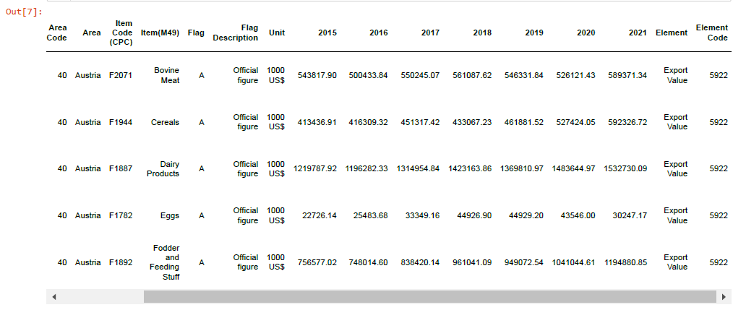

Figure 1: EU crops and livestock productions trade data frames

## Observing and describing data

1- Dropping the redundant columns.

We will drop the redundant columns to make the data set easier to visualise. To determine which columns are not necessary for the analysis. We defined a **displayColumnsValues()** function to have a deep look at all the columns' values in our data set.

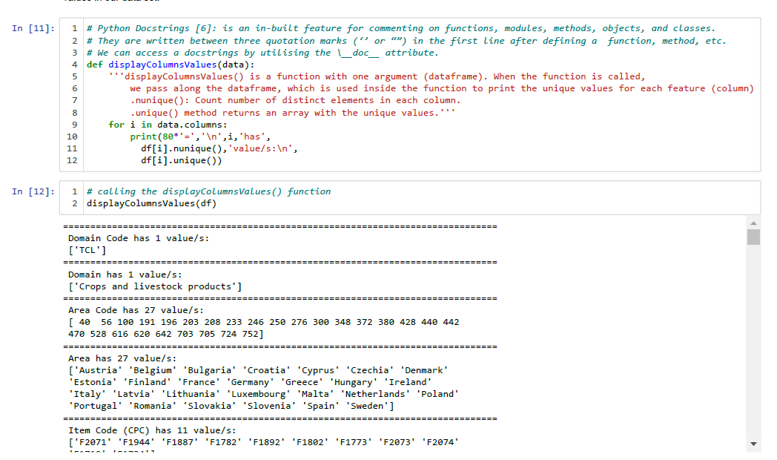

Figure 2:The unique columns values

Now we can drop Unnecessary columns that do not help in our analysis like:

* ‘Area Code (M49)’, ‘Flag’, ‘Flag Description’, ‘Unit’ --> contain only one value, not add any new information for the analysis,
* ‘Domain Code’, ‘Item Code (CPC)’, ‘Element Code’ --> will use the ‘Domain’, ‘Area’, ‘Item’, and ‘Element’ instead,

Which method del or .drop() to drop the columns?

* del is an in-place operation, delete one column at a time.
* .drop() can use on both columns or rows, drop one on multiple items at a time, and operate in-place or return a copy [4].

We are going to use .drop() to drop the previous columns. Unnecessary columns dropped from the data frame to make the focus on the remaining columns easier as shown in Figure[3].

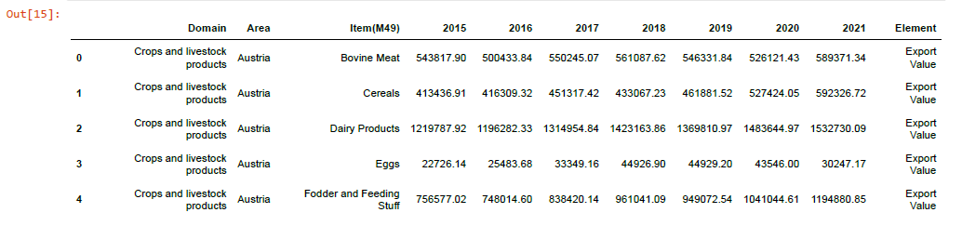

Figure 3: Dataframe after dropping the unnecessary columns.

2- Renaming the columns for clarity.

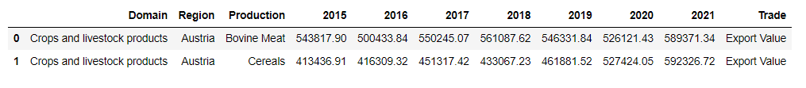

Figure 4:Renaming columns.

3-Put all the price in Millions $ instead of Thousand $.

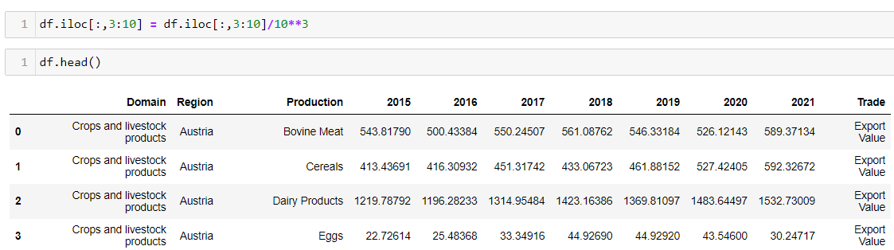

Figure 5: Change the unit of the price to $M instead of $K

4- Replace the values in 'Trade' column for easier reading.

*.*replace() method applied to the ‘Trade’ column to replace the ‘Import Value’ to ‘Import’, and the’Export Value’ to ‘Export’



Figure 6:Replace the values in 'Trade' column.

5- Add new column 'Total Gross'

.insert() to insert the new column 'Total Gross' has the total prices of each crops and livestock products over 2015-2021 in a specific position 12

.sum() method used to return the sum of values over rows (axis=0) or column (axis=1)



Figure 7: Add the new column 'Total Gross'

6- Observing the dataset.

A quick look at our data again.

*.info(): return all information about the dataframe*

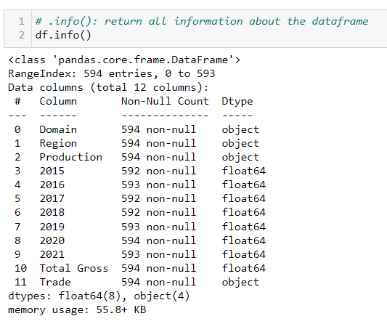

Figure 8: The dataframe information.

The data set contains a mixed type of data (object, int64, and float64).

* Some null/missing values observed. We cannot change the data type before looking at the missing values.
* We will change the dtypes for some columns after cleaning the data.

.describe() Generate descriptive statistics for the numeric columns, it summarize the central tendency, dispersion and shape of a dataset’s distribution, excluding NaN values.

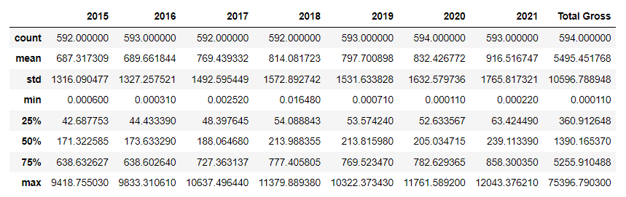

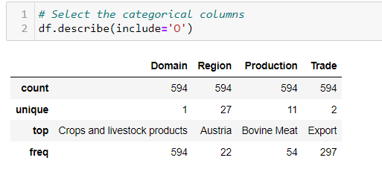

Figure 9: .describe()

Count: gives the total values for each column. It appears that '2015','2017','2018' have 2 missing values and '2016','2019','2021'contain one missing value each.

* Range = max - min the range of data for: '2015' is 0-9418.7 '2016' is 0-9833.3 '2017' is 0-10637.4 '2018' is 0-11379.8 '2019' is 0-10322.3 '2020' is 0-11761.5 '2021' is 0-12043.3 'Total Gross' is 5495.45 - 75396.790
* All the year features have the minimum value of zero because some of the import and export productions over the time series from 2015-2021 may not be traded in any EU country at a specific year.
* IQ3 or 75% values for the year columns '2015'-'2021' are considered small regarding its maximum values, which indicates an outlier not clear if this outlier on the import prices or export prices will see later.

For the object data type. The result includes 'count', 'unique', 'top', and 'freq' 'top' gives the most common values while 'freq' gives the most common value frequency.

**6- Cleaning Data.**

**Duplicate values:**

.duplicated().any(): checking the duplicated values:

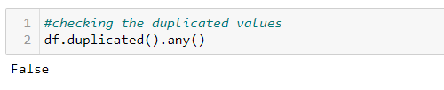

Figure 10: .duplicated()

No duplicated rows were observed in our data set.

**Missing values**: are a common issue in some data sets for many reasons, such as corrupted data or unrecorded observations.

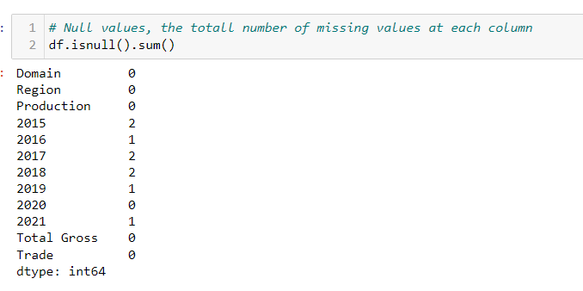

Figure 11: Missing Values

Our data set contain missing values, Let's have a deep look to the missing values by displaying the percentage of the missing values as shown in Figure[12].

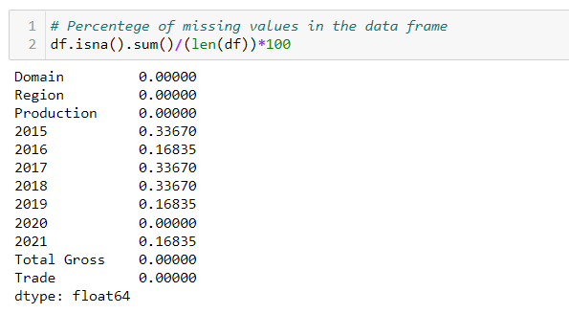

Figure 12: Missing value percentage

The percentage of missing values between 0.16% to 0.33%, which can be dropped without any effect on our analysis.

7- Change the data type for some features

After cleaning the data. It’s a time to change the data type of some features for the data visualisation and graphing purpose, the price(€m) for the exported crops and livestock productions displayed on the columns '2015' to '2021' are float64. We changed them to int64, Python rounds down when it converts from floating point to integer.

## Data Visualisation:

To better understand the data set, we are using the powerful modules like a seaborn and matplotlib to have a deep look at the statistical distributions of our features.

**Why is color significant when displaying data?**

Color is crucial in data visualization because it enables you to draw attention to specific information and recall information later. In order for viewers to clearly see major differences or similarities in values, different colors can be used to separate and define different data points within a visualization. To make presented data more memorable, color choices for data visualization should take into account color theories and frequent color associations. Depending on the goal of the visualization report, colors might affect how viewers see data and convince them to feel either positively or adversely [Yi, M. (n.d.)][ Schloss, K.B., Gramazio].

To be precise, we will use tw colours for all import and export products in Ireland:

* 'Firebrick', for the import because red can be understood for backward progress.
* 'Green', for export as it gives the feeling of nature and achievement.

**Pairplot:**  is a method from the seaborn library used to get a nice visualisation plot for the pairwise correlation between all the variables on our dataset. the pairplot considered a simple tool to understand the data set by summarizing it in one figure as displayed in Figure [13].

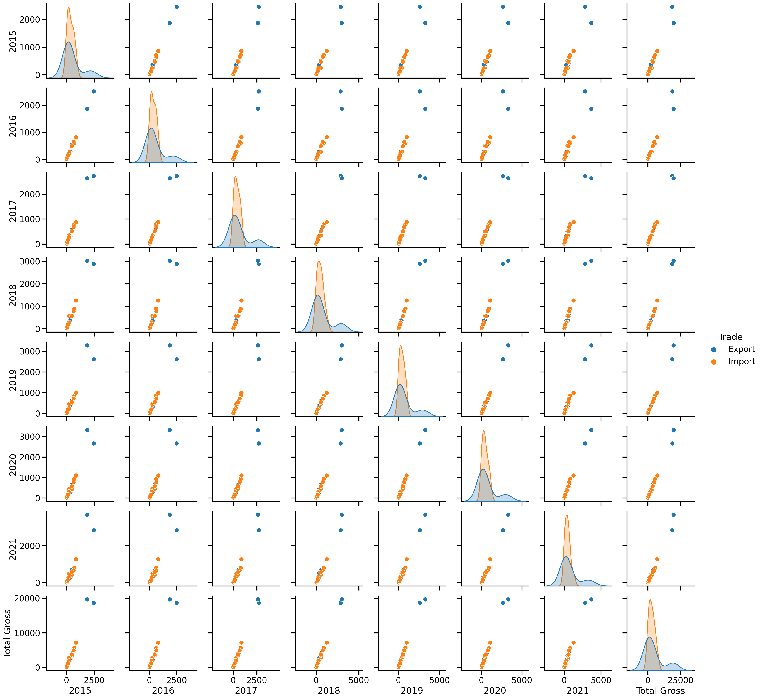

Figure 13: Pairplot for df_Ireland

**Heatmap:** is a two-dimensional plot of the correlation strength (a measure of dependence) between the variables represented by color. The correlation amount is represented by the color intensity variation on the heat map. The correlation range is between -1 and+1. There are two types of correlation positive correlation (closer to 1) and negative correlation (closer to -1). The correlation between every two columns on the data set can be represented by a square. All the values on the diagonal are 1 because it is correlating each variable to itself. The correlation between each column in df_Ireland shown in the next Figure [14]:



Figure 14: Heatmap for df_Ireland

The heatmap shows a strong positive correlation between the columns in our data set.

It’s a time to answer the questions:

**Q1: ’What is Ireland's total external trade of crops and livestock products over 2015-2021?’.**

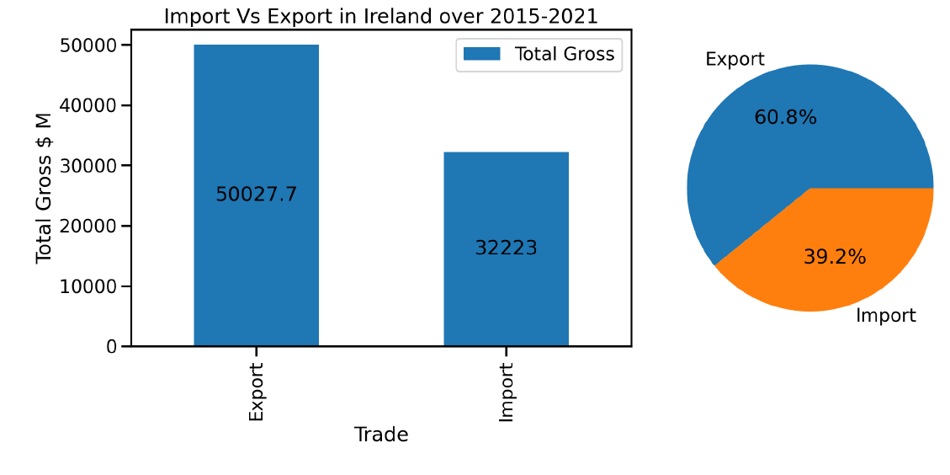

Figure 15:Import and export in Ireland over 2015-2021

Figure [15] shows Ireland's total external trade in crops and livestock products over 2015-2021 amounted to Euro $82250 million. Of this total external trade, $50027 million (60.8%) Were exported crops and livestock products, while $32223 million (39.2) were imported crops and livestock products. The values of crops and livestock products imported and exported by Ireland over 2015-2021 appears in Figure [16] and [17]:

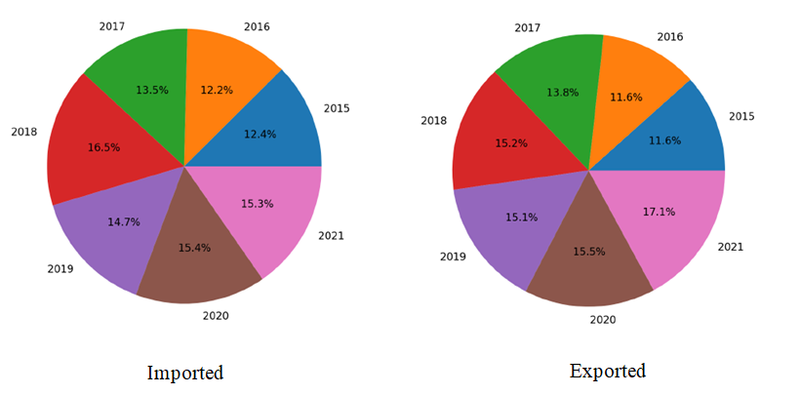

Figure 16: Values of crops and livestock products in Ireland over 2015-2021

This pie chart for the imported crops and livestock products in Ireland over 2015-202 shows a gradually increased from 12.4% in 2015 to 15.3% in 2021. on the other hand, the pie chart for export products depicts an increment rate percentage in Ireland's exported crops and livestock products over 2015-202. it was 11.6% in 2015 and was increased to 17.1% in 2021.

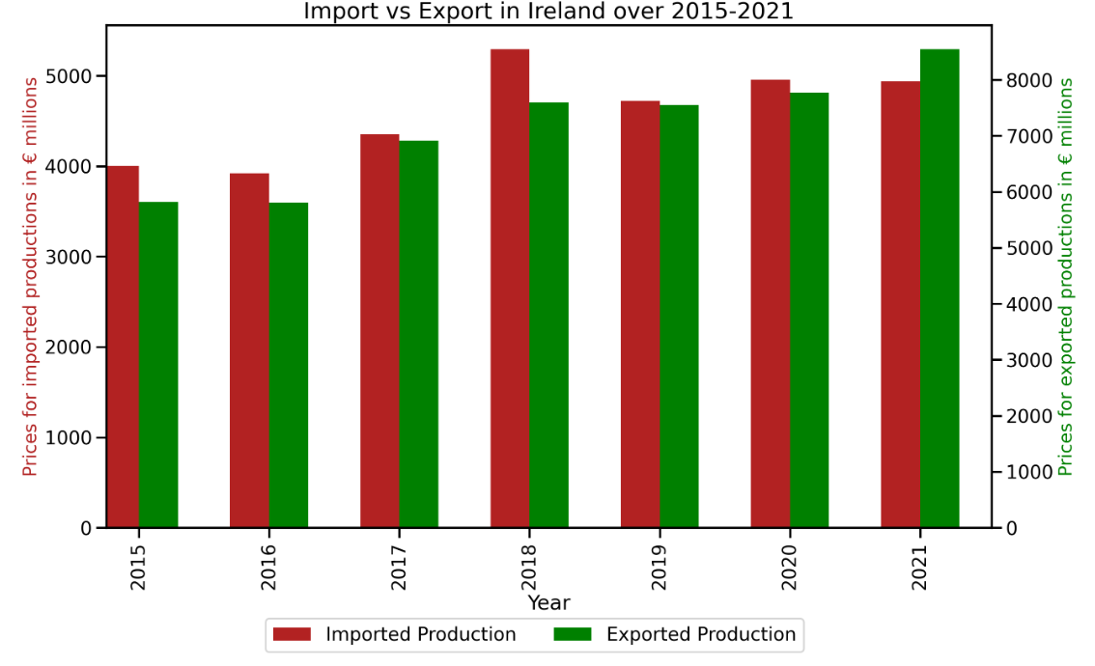

Figure 17: Bar-plot for Import vs Export in Ireland over 2015-2021

Figure [17] depicts the bar graph depicts that in general the import is more than the export as we can see in 2015,2016, 2020. A small trade deficit between import and export are noticed in 2017 and 2019. So proud to see that after the tough time of Covid-19. Ireland exported exceeded the imported values.

**Q2: What is the top agricultural production in Ireland?**

Figure [18] depicts different crops and livestock products trades value in Ireland over 2015-2021 which gives the answer to the second question:

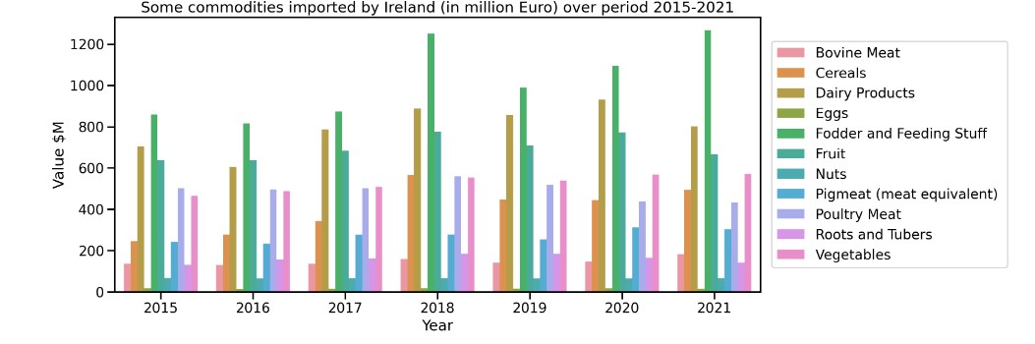

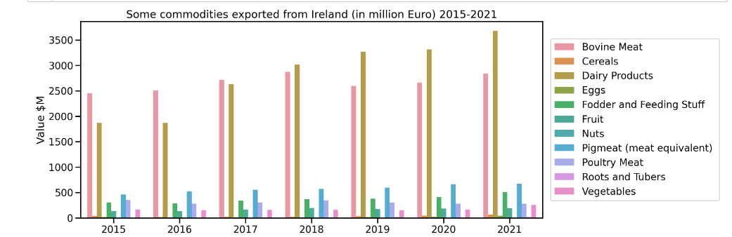

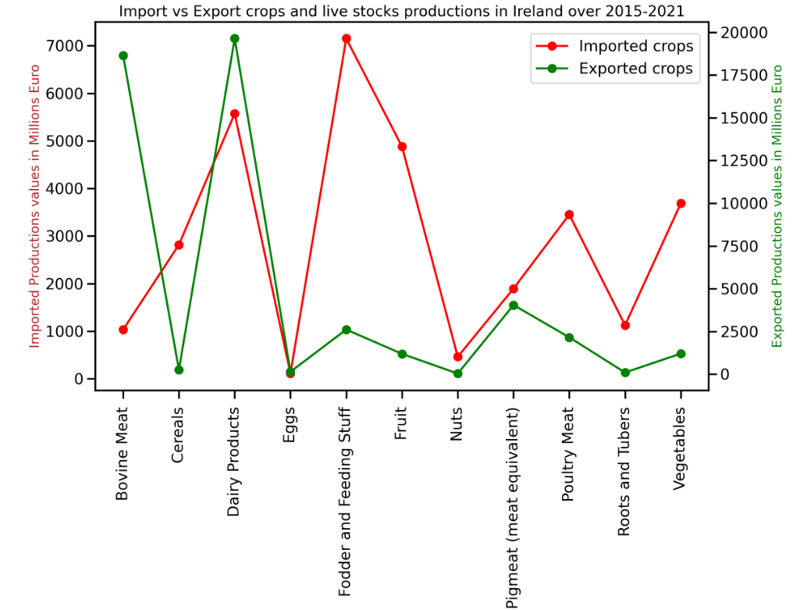

Figure 18: Crops and live stocks in Ireland

The most imported products in Ireland are the 'Fodder and feeding stuff' While the 'Diary Products' is the most exported products from Ireland over 2018- 2021 where 2015-2018 the ‘Bovien Meat’ was the most export products from Ireland. That dairy products include (Butter from cow milk, Buttermilk, curdled and acidified milk, cheese from whole cow milk, Cream, fresh, processed cheese, Raw milk from cattle, Skim milk and whey powder, Skim milk of cows, whey(condensed),

Whey(dry), Whole milk powder, Whole milk(packed), Whole milk(evaporated), and Yoghurt (with additives)).

The stacked area plots were created for both import and export ordered data frames for Ireland, each row of the data frames is represented as the vertex of a polyline mark in 2D space. The area between successive polylines is filled as shown in Figure [19].

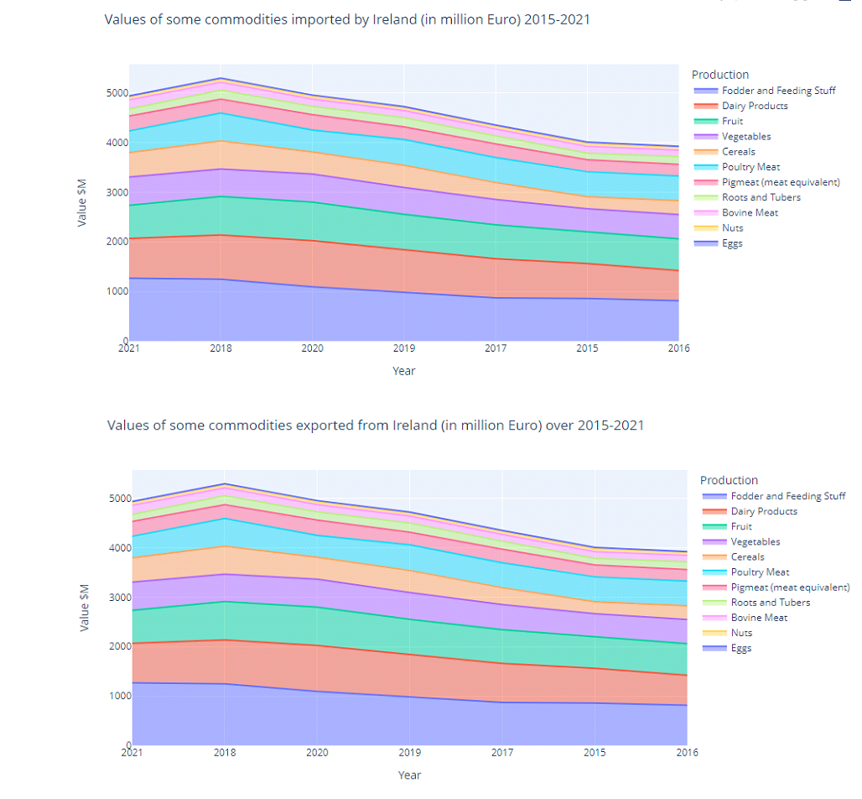

Figure 19:Stacked area Plot for Import & Export products in Ireland

**Histogram:**

provides a visual representation of the frequency at which each value in a data collection occurs. It shows the distribution of a numeric variable, grouping data into bins. The height of the bar represents the number of observations per bin.

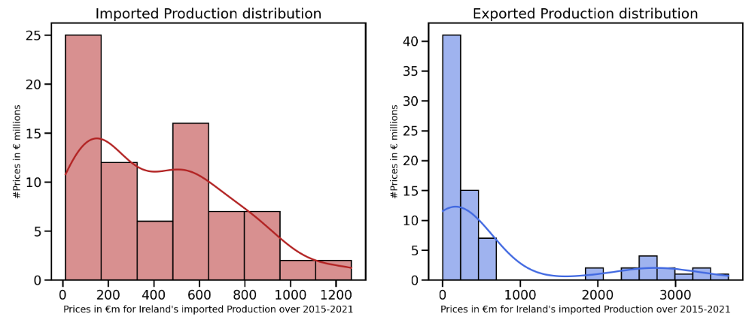

Figure 20: A histogram for Import and Export features for Ireland

Figure [20] shows that right skewed distribution for both features.

Line plot:

The most popular, chart type. We used it to depict the quantitative values in $M of import and export crops and livestock products in Ireland over 2015-2021 as shown in Figure [18]. 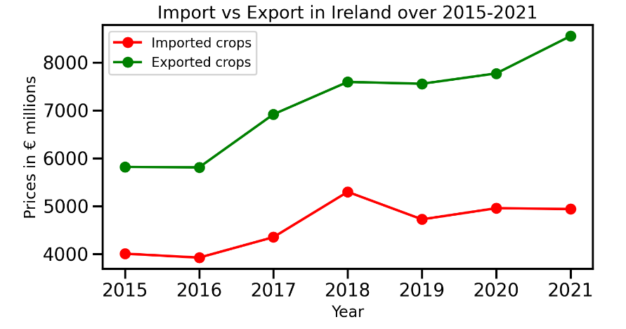

Figure 21: Line-graph for Import vs Export in Ireland over 2015-2021

**GO-Figure!** is a great tool that can use to create a visual summary of lists of GO terms. This is useful for data analysis and comparisons of different datasets. created in figure [22] to add to the dashboard later.

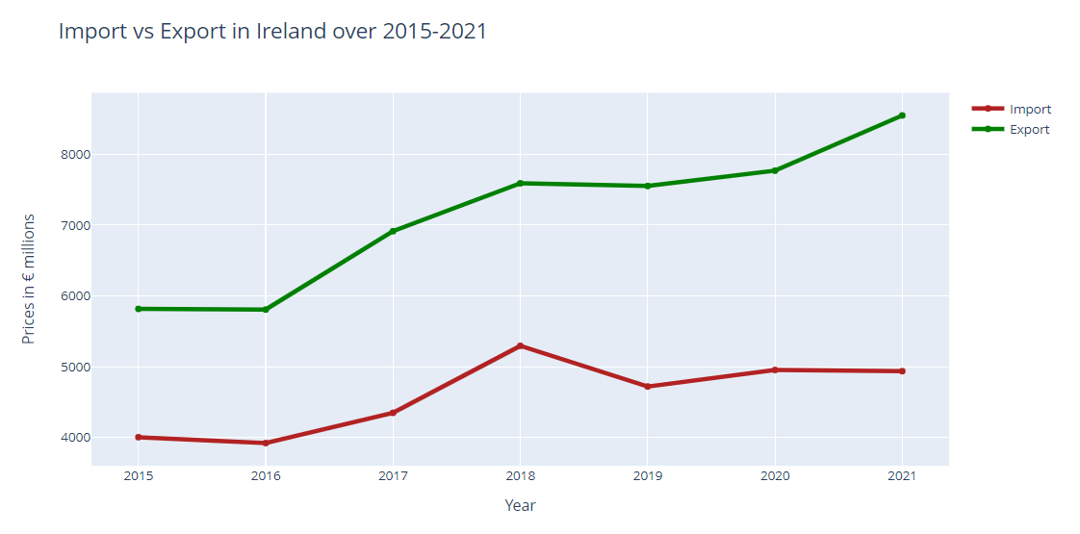

Figure 22: Go-Figure for Import and Export in Ireland

In 2018, the trade rate for imports and export increased. The imported products reached 5259 million Dollar, the highest import rate from 2015-2021. at the same time, the exports became 7590 million Dollar. In 2019 the trade rate began to decrease again. In 2021, the exported trade reached its highest rate of 8548 million Dollar.

We also Created a stacked horizontal bar chart for the import and export crops and livestock productions in Ireland over 2015-2021 in Figure [].

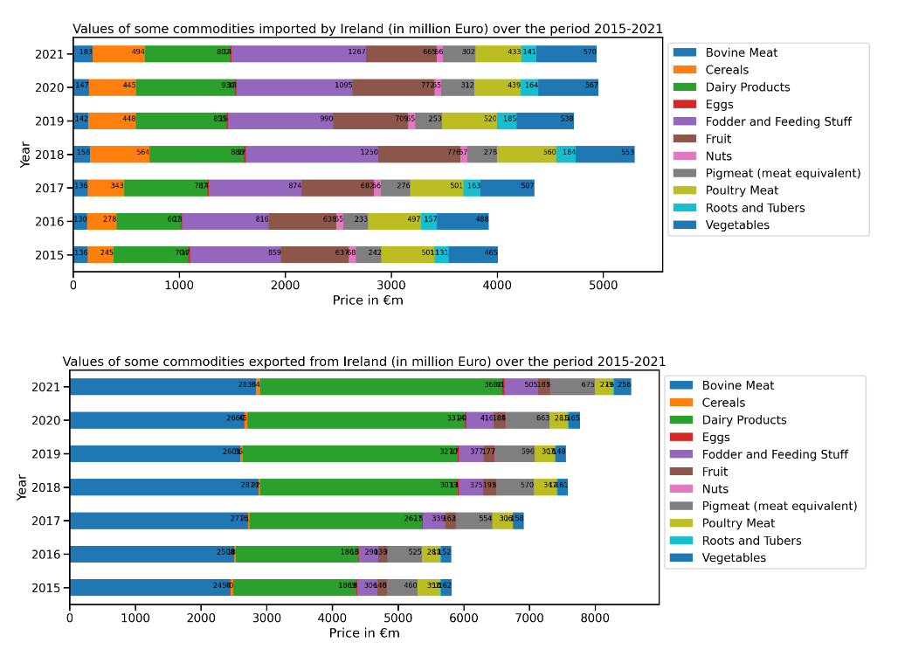

Figure 23: stacked horizontal bar chart for the import and export products in Ireland.

## Compare export commodities for Ireland with other Europe Country

Instead of filtering the main dataframe to extract the export items only. We are going to read the export file

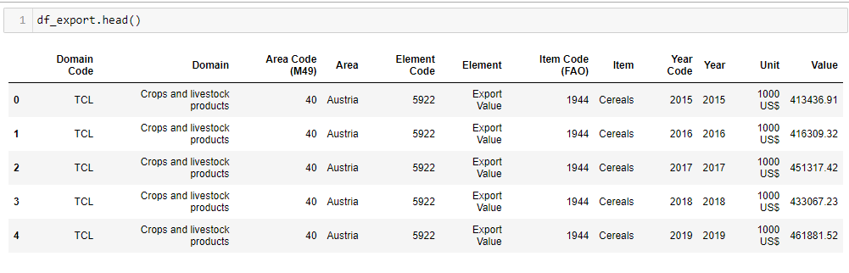

We compare the export commodities for Ireland with all European Union countries over 2015-2021 using the choropleth plot.

**Choropleth-plot:** is a colored polygons map used to depict and represent spatial variations of a quantity.

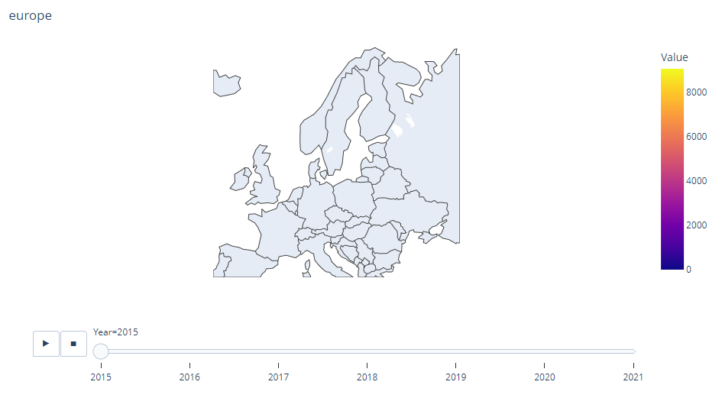

Figure 24: Choropleth- plot for Agricultural export in EU countries over 2015-2021.

From figure [24] It seems the choropleth plot is not displaying any colours for any country. It may be for using the numeric code of the country 'Area Code (M49)'. Let's try to use the country abbreviations according to the International Organization for Standardization (ISO)- ISO 3166-1 alpha-3.

Read a countryCode CSV file as displayed in Figure[25]:

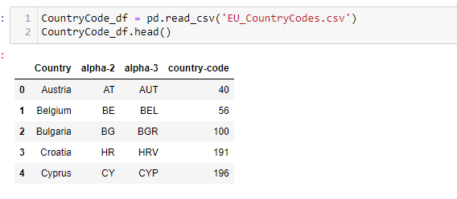

Figure 25: CountryCode

We Convert the two columns 'Country' and 'alpha-3' to a dictionary to add a new column 'alpha-3' to the data frame 'df_export' as shown in Figure [26]:

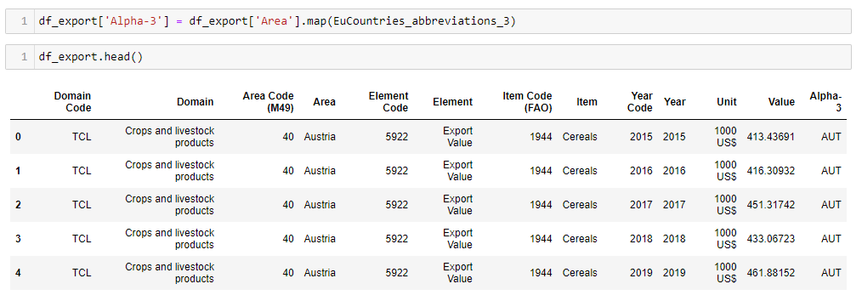

Figure 26: df_export data frame after adding 'alpha-3' column.

Let’s try again a choropleth plot using the International Organization for Standardization (ISO)- ISO 3166-1 alpha-3:

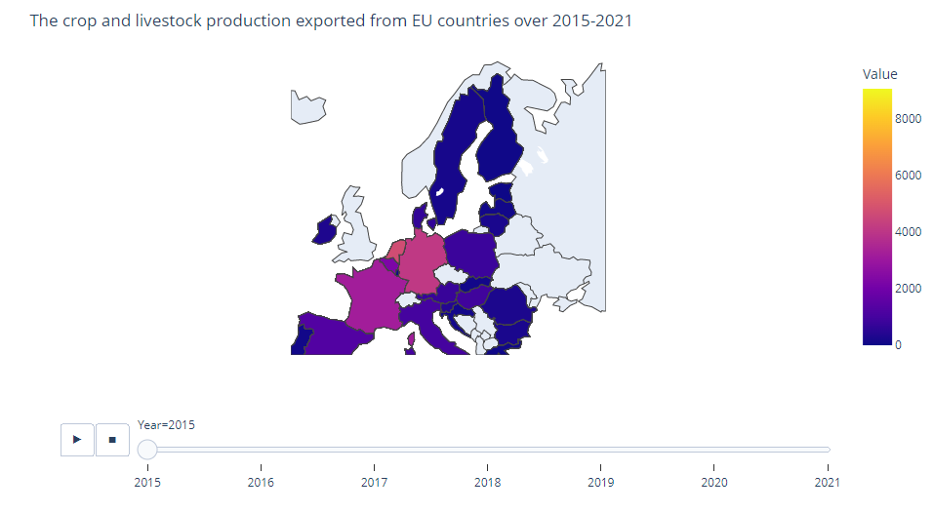

Figure 27: Choropleth- plot for Agricultural export in EU countries over 2015-2021 using the alpha3-for the location.

The darker regions indicate fewer exported values in $M, while the lighter ones indicate a high amount of exported values in $M. It is clear that the top 5 countries are the Netherlands, France, Spain, Belgium, and Germany. Poland's export value doubled from 2015 (1287) to 2021(2258 $M). Ireland's export also increased from (40.60) $M in 2015 to (64.71) in 2021.

## An Interactive Dashboard with Panel:

What is Panel? Panel is an open-source python library that can be used to create interactive web apps and dashboards.

**The Panel Widget used:**

* Slider, the IntSlider widget enables selecting an integer value within predefined bounds.
* RadioButtonGroup widget is used here to create toggle buttons to select values from a list or dictionary.

We created a dashboard consisting of two parts side and main. The side contains abstract and image while the main part has four interactive figures for the value of export crops and livestock products over 2015-2021, as shown in Figure [28]:

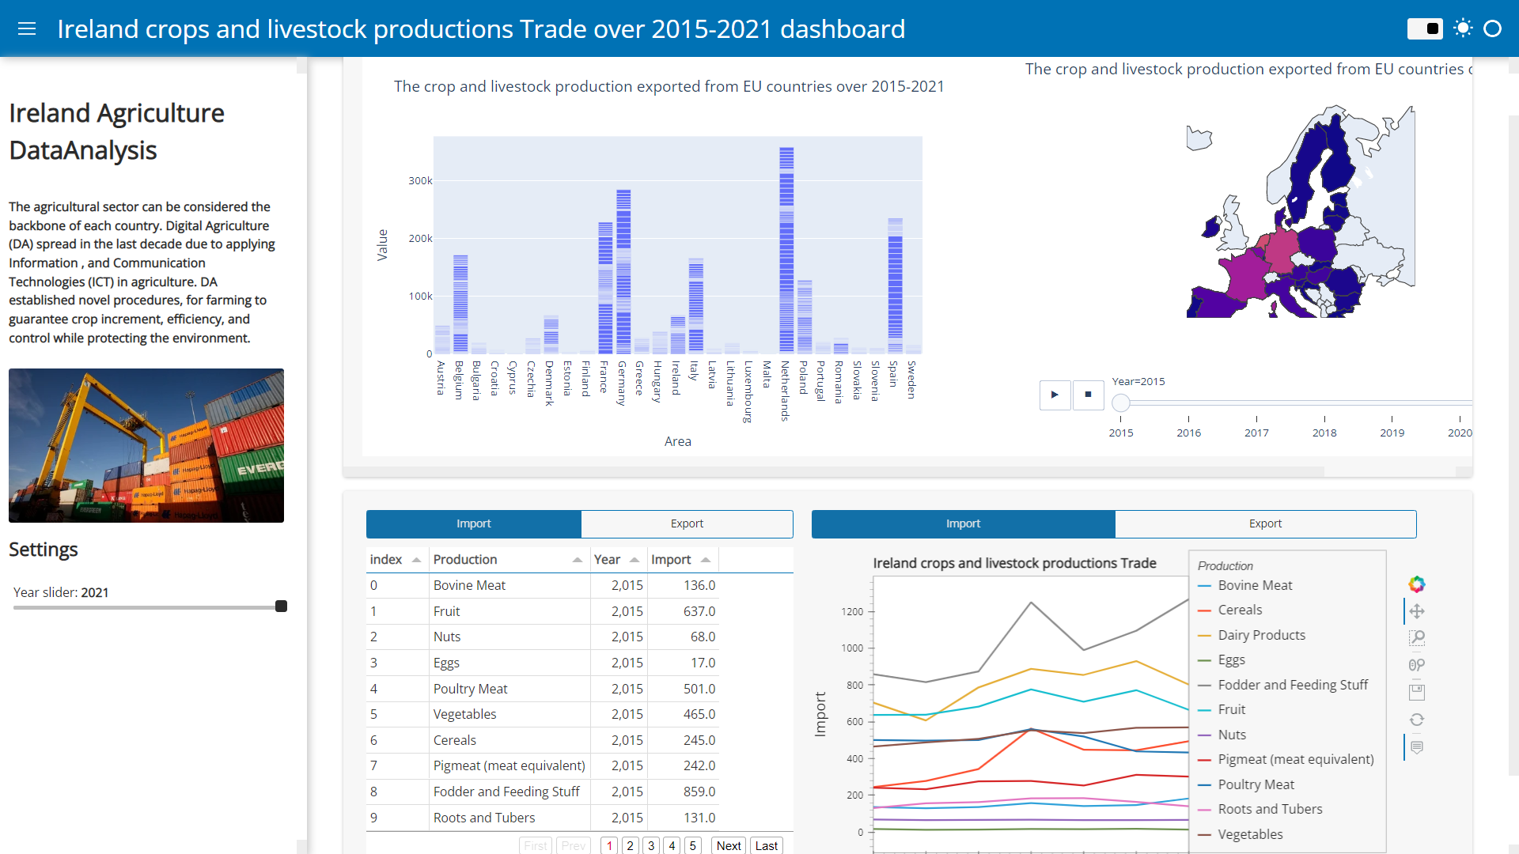

Figure 28: Ireland crops and livestock exported products over 2015-2021

## ****Feature Engineering:****

The Ireland imports and exports of the crops and livestock production dataset contains categorical and numeric features. Before building a machine learning model, we should make preprocessing steps on the data. The regression model can be fed with numeric features only to apply. In this case, the dummy variables will replace the categorical features.

1- conversion of categorical variables to numerical variables:

We have many encodings to convert the categorical data into numeric data:

* **Label Encoding**: The categorical values in the column will be encoded with a value between zero and the number of classes-1.
* **Ordinal Encoding** (integer encoding): The categorical values should be in an ordinal relationship to apply ordinal encoding. The ordinal encoding converts each unique category value into an integer value starting from zero to the number of classes-1
* **One Hot Encoding & Dummy Variable Encoding:** It splits the categorical column when no ordinal relationship exists into multiple columns(n), where n is the number of columns equal to the unique values in the categorical column. Each column contains binary values to indicate the presence or absence of a category with a value of 1 or 0, respectively.

We will build ML models for both classification and prediction. The scikit documentation advises using a label encoding with the target variable. We will use **label encoding** to map **the target values in the 'Trade' columns**. Moreover, the **one-hot encoding** with the feature **'Production'** to avoid the ML model misunderstandings during the training stage. Scikit-Learn's DictVectorizer method will encode our categorical columns to numeric.

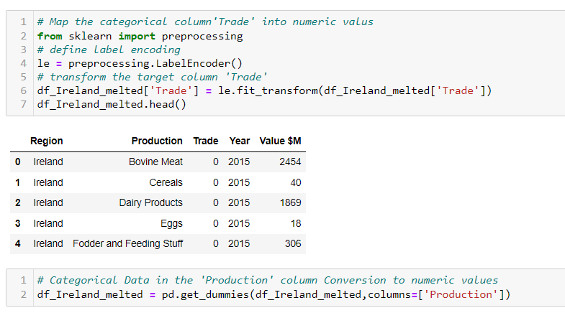

Figure 29: Encode the target feature’Trade’

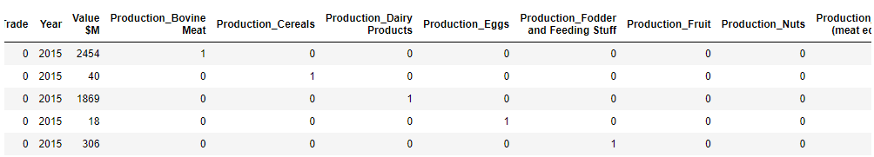

Figure 30: Encode the 'Production' feature.

Have a deep look at the data t know if the features need to rescale or not:

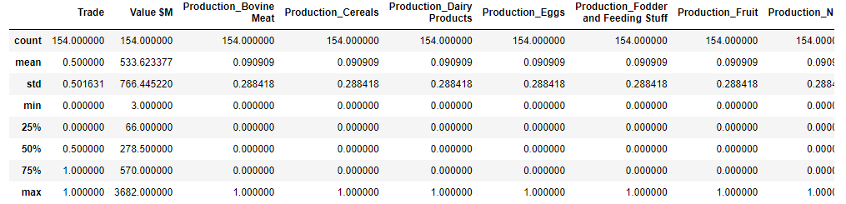

The minimum for 'Value $M' is 3 while the maximum is 3680 million Euro. So the crop and livestock production trade price in the 'Value $M' column must rescale before building a ML model.

Rescaling data

The most popular concepts to rescale a numeric data are:

* **Normalization**: All the numeric features rescaled to the range between [0-1] using the formula:
$$X_{norm}= \frac{x-x_{min}}{x_{max}- x_{min}}$$

* **Standardization**: Standardization is transforming the numeric feature with Gaussian distribution to standard normal distribution by subtracting all values from the mean value ($μ$) and then dividing by the standard deviation value ($σ$):

$X_{stand}= \frac{x-μ}{ σ}$.

We will scale the 'Value $M' column later in Machine Learning Section.

# Machine Learning:

Machine learning is the science of getting computers to act without being explicitly programmed. It has four types as shown in figure19:

* Supervised machine learning algorithms.
* Unsupervised machine learning algorithms.
* Semi-supervised machine learning algorithms.
* Reinforcement machine learning.

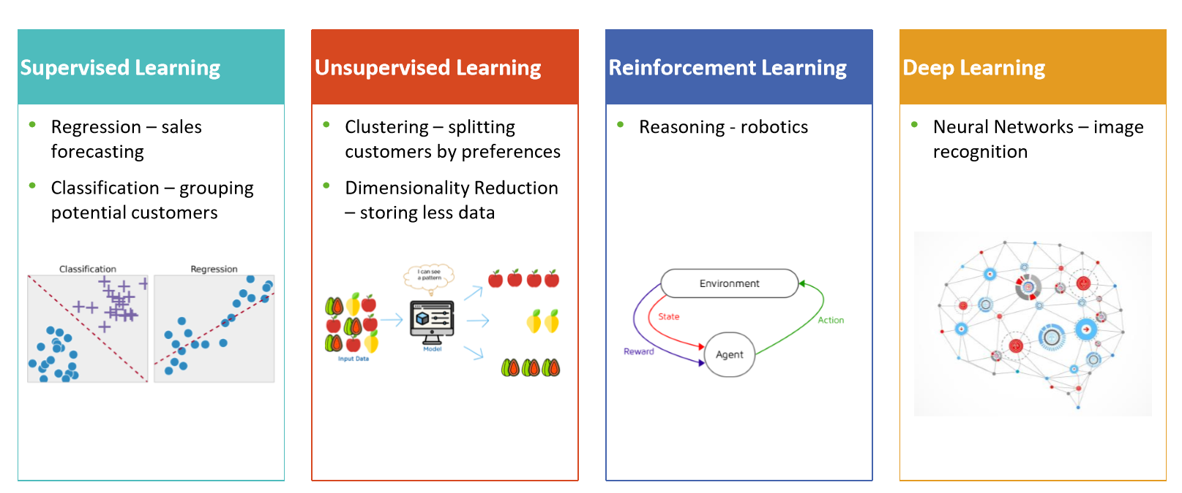

Figure 31 : Types of Machine learning

Choose the appropriate Machine Learning Algorithms depends on::

* labeled or unlabeled datasets.
* The dataset size and the structure of the features.
* What we want to get from this data?

We have a labeled dataset so we will apply a Supervised ML but which one? To know the appropriate ML model, we check the sample size. We will study the dataset for Ireland only which is small. It is 154 observations(rows) and 14 columns.

We will apply the machine learning algorithms to the Ireland dataset. We will use the classifications algorithms to classify Ireland's crops and livestock productions according to the prices from 2015-2021 into binary classes, import and export. Also, we apply different regression algorithms to forecast the export trade prices of various crops and livestock productions in the coming five years in Ireland.

Methods

In this assignment, we started by performing data processing to guarantee high performance from the ML models. Then, different data mining algorithms were applied to classify the given dataset into binary classes (0:’Export’, and 1:’Import, namely K-nearest neighbors-(KNN), Decision tree, Random Forest, Naïve Bayes, Support Vector Machine, also we applied the cross-validation technique with most of them. Also, We used different regression algorithms to predict the value of crops and livestock products export in the coming five years .

Let’s have a look to the target column ’Trade’ to know if we have a balanced dataset or not:

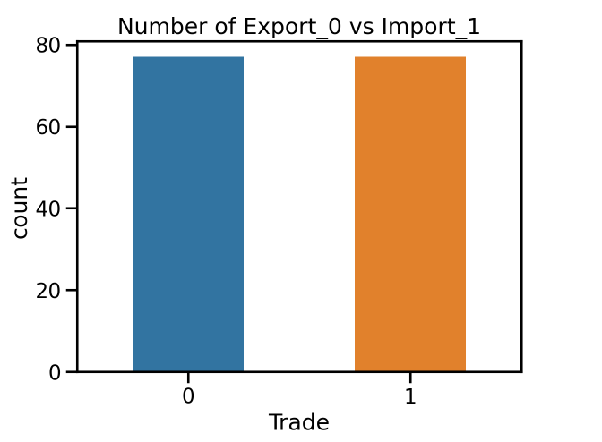

Figure 32:Import vs Export class numbers

Great, Figure [32] depicts that we have a balanced dataset.

## Data Preprocessing:

The Ireland dataset has been loaded and extensively analyzed in the Data Visualization Section. Data preprocessing is an essential step in machine learning before feeding the data into ML model to ensure the quality of the model and assure high performance. The preprocessing included:

* **Rescaling data:** We discussed it previously.
* Splitting the dataset

The dataset will be split to two datasets, the training dataset and test dataset. The data usually tends to be split inequality because training the model usually requires as much data-points as possible. The common splits are 70/30 or 80/20 for train/test.

The training dataset is the initial dataset used to train ML algorithm to learn and produce right predictions. (70% of dataset is training dataset) The test dataset, however, is used to assess how well ML algorithm is trained with the training dataset. We used 80/20 here.

## Supervised Machine Learning Classifier Overview

K Nearest Neighbors (KNN):

KNN classifier is the best algorithm fit for our case study scenario because KNN is based on feature similarity. It is considered the simplest machine learning algorithm. In figure 20, A data point is classified according to the classifications of its k-neighbors.

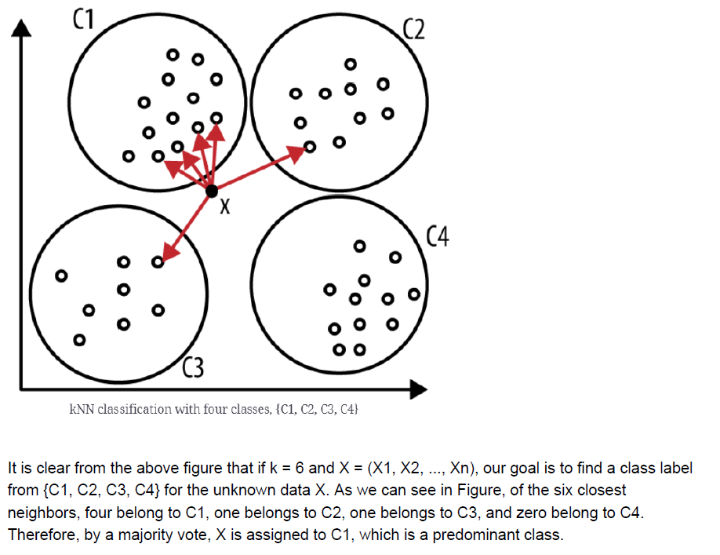

Figure 33: KNN classification

There are many ways to measure the distance between the new datapoint and the nearest k points:

Euclidian: $d_{euclidian = \sqrt{\sum_{i=1}^{n}{{(x_{i}-y_{i)}}^{2}}}}$

Manhattan: $d_{Manhattan = \sum_{i=1}^{n}{|x_{i}-y_{i}|}}$

Minkowski: $d_{minkowski}={(\sum_{i=1}^{n}{{|x_{i}-y_{i}|}^{p}})}^{\frac{1}{p}}$

In order to decide the best value for hyperparameter k (number of neighbors), We need to train and test your model on 10 different k values and finally use the one that gives the best results. Let's initialize a variable neighbor(k) which will have values ranging from 1-9 and two numpy zero matrices namely train_accuracy and test_accuracy each for training and testing accuracy. We need them later to plot a graph to choose the best neighbor value.

|  |  |  |
| --- | --- | --- |
| train_accuracy | test_accuracy | It looks like the best k-value is k=2 |
| 99.18699187 | 54.83870968 |
| 72.35772358 | 64.51612903 |
| 92.68292683 | 54.83870968 |
| 76.42276423 | 54.83870968 |
| 77.23577236 | 48.38709677 |
| 70.73170732 | 54.83870968 |
| 78.86178862 | 61.29032258 |
| 65.85365854 | 54.83870968 |
| 79.67479675 | 61.29032258 |
| 57.72357724 | 41.93548387 |

Decision tree (DT):

A decision tree is a popular supervised ML model for classification and regression tasks. They learn a hierarchy of if/else questions, leading to a decision. It automatically constructs a tree from a given dataset to ﬁnd the optimal decision tree by minimizing the generalization error. However, other target functions can also be deﬁned, for instance, minimizing the number of nodes or the average depth. The root/node splits into sub nodes to create a pure node based on different techniques according to the target variable type, if continuous values: we use reduction in Variance, If categorical values: we can use one of the following [Zaki, M.J. and Wagner Meira (2020]:

* Gini Impurity
* Information Gain
* Chi-Square

To determine the best value for Max_depth, we train the model for different Max_depth values and got the accuracy as shown in Figure [34]:

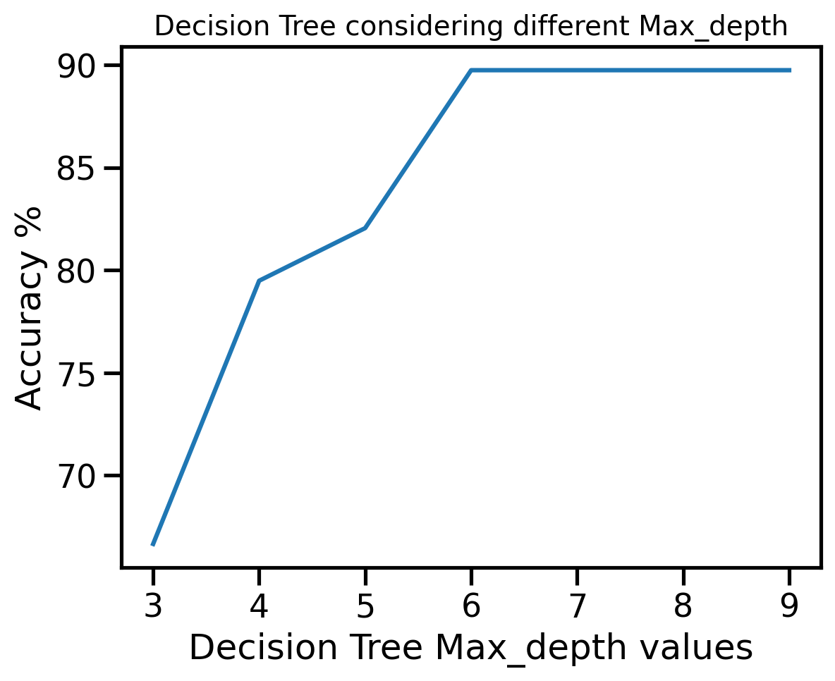

Figure 34: Different values for Max_depth

It looks like that the best value is between 5 and 7, we train the model with Max_depth=6

|  |  |
| --- | --- |
| **Max_depth** | **Accuracy** |
| 3 | 66.66666666666666, |
| 4 | 79.48717948717949, |
| 5 | 82.05128205128204, |
| 6 | 89.74358974358975, |
| 7 | 89.74358974358975, |
| 8 | 89.74358974358975, |
| 9 | 89.74358974358975 |

Figure 35:Accuracy for different Max_depth values in Decision Tree

The decision tree visualization displayed in Figure [36]:

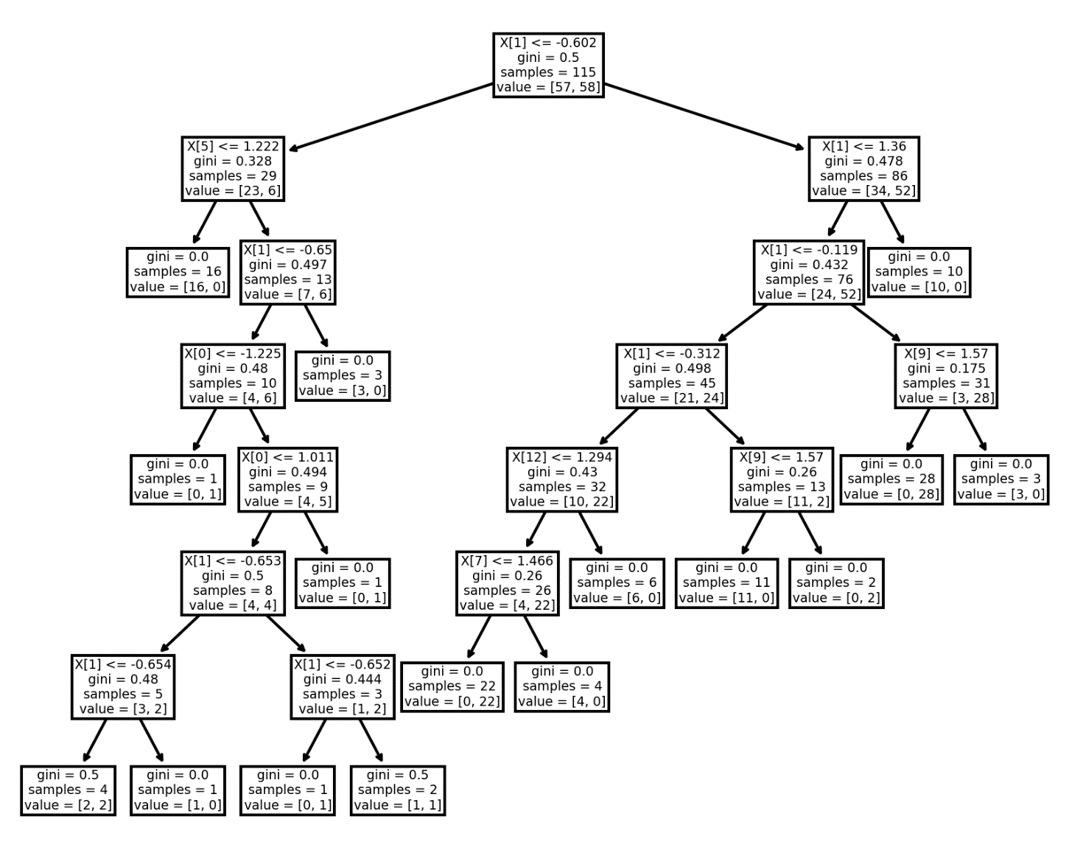

Figure 36: Decision Tree Plot

Random Forest (RF):

Is a supervised ML model for classification and regression. It is also the most flexible and easy to use algorithm. A forest consists of trees. It is said that the more trees there are, the more robust a forest is. Random Forests builds decision trees on randomly selected data samples, obtains predictions from each tree, and selects the best solution by voting. It also provides a pretty good indicator of the importance of the feature. How it works? The difference between RF and decision tree in the figure [37]:

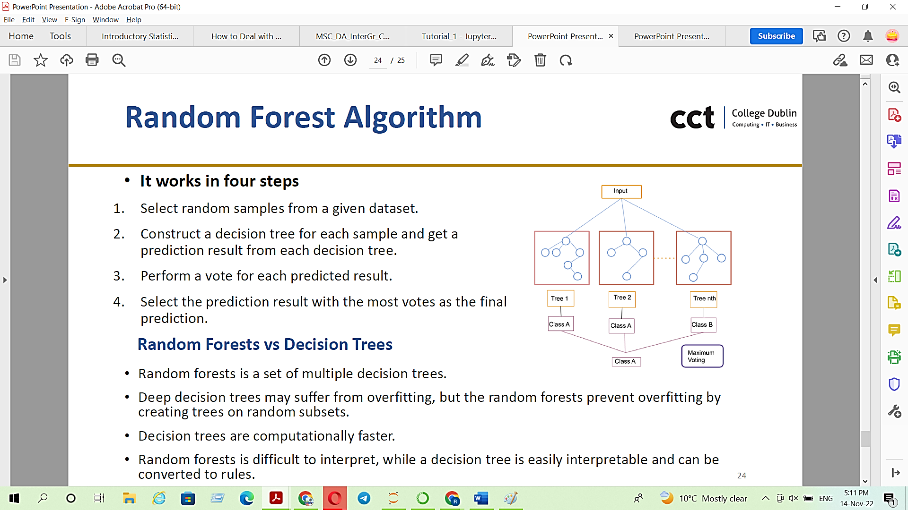

Figure 37: Random Forest algorithm, RF vs DT

The hyper parameter for the Random Forest is the **n_estimators,** it is a number of trees in the forest. figure [38] gives the model performance (testing accuracy) vs different n_estimator values.

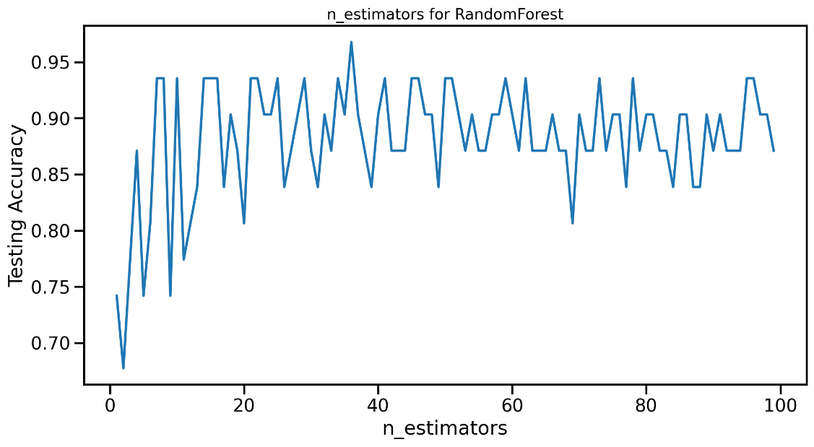

Figure 38: Testing accuracy for RF vs different n_estimator values

We can see that we can stop at n_estimators = 35.

## Naive Bayes Classifier (NBC):

Is a supervised and probabilistic learning method. It performs effectively when the inputs are independents.

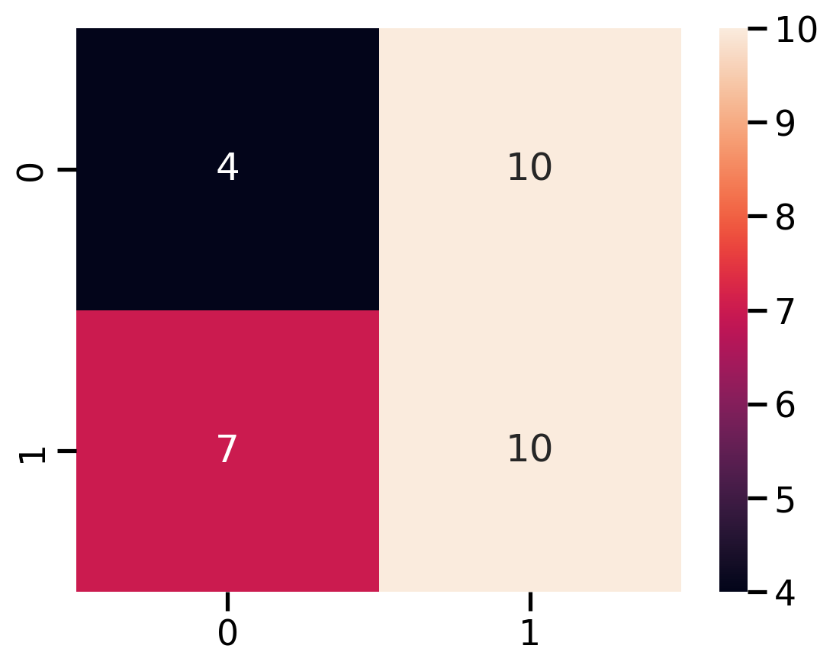

Figure 39: Heatmap for NBC

The confusion matrix for NBC indicates that from the test set 31(20%) there are:

* **7** observations are ‘True positive’ (classified as ‘Export’ class predicted to be ’Export’.) while **11** are ‘True negative’ (‘Import’ class predicted as ‘Import’.)
* **13** are classified as a ‘False Positive’ (‘Import’ class was predicted as ‘Export’. [Error Type I] and **8** are classified as a ‘False Negative’ ( ‘Export’ Class Predicted ‘Import’. [Type 2 error]

The NBC accuracy is 45.16%

Support Vector Machine (SVM):

Support Vector Regression Support Vector regression is a type of Support vector machine that supports linear and non-linear regression. In simple regression we try to minimise the error rate. While in SVR we try to fit the error within a certain threshold. As it seems in the below graph, the mission is to fit as many instances as possible between the lines while limiting the margin violations. The violation concept in this example represents as ε (epsilon).

The most hyperparameters for (SVM) are C (control the misclassification cost) and Gamma (parameter for Gaussian Kerenal). Trained the model with gamma=0.9and difference C value shown in Figure[]

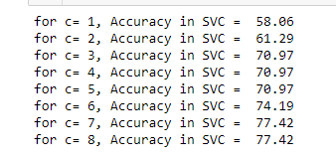

Figure 40: Hyperparameters for SVM

**Regression**: is one of the predictive models that consider the correlation between the target variable(s)(independent) and a predictor(s)(dependent).

Linear Regression:

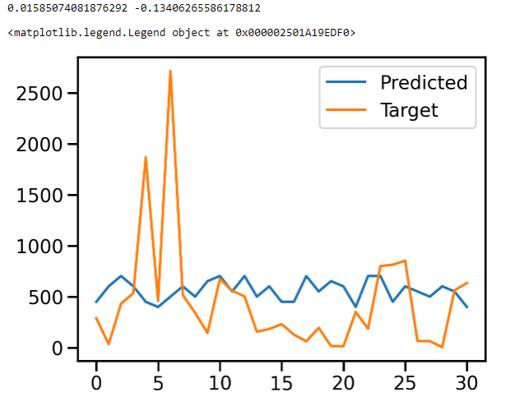

Figure 41Linear regression: predicted values vs Target values.

The accuracy is: 0.01585074081876292 whie the r2 is: -0.13406265586178812. The R-squared of the model in training set is: 0.0158 and R-squared of the model in test set is: -0.1241. That means linear regression performance is inferior and not suitable for our dataset. The Linear regression tries to fit a straight line, but the -ve result indicates that the relation between the 'Value' column and the 'Year' is complex and non-linear.

**Ridgr regreesion:** it is considered as the Linear regression extension while the loss function updated to reduce the complexity of the model and, therefore will improve the performance. We used theGridsearch to optimize alpha but unfortunately got the same result.

## k-Fold Cross-Validation:

Cross-validation is a resampling process used to evaluate machine learning models on a limited sample of data. A single parameter k integrated to refers to the number of groups to which a given sample of data should be divided. Therefore, this procedure is often namely as a k-fold cross-validation. It is mainly used to estimate the machine learning model skills on unseen data and mostly leads to less biased. model.

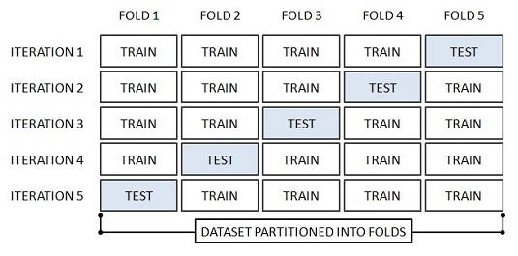

Figure 42: How cross validation work

Model evaluation:

**Confusion matric** and classification report are two main tools used to measure the performance of the ML models on the test data.

**Confusion matrix** there are four possible outcomes when performing a classification:

* True positive → positive class predicted to be positive.
* True negative → negative class predicted as negative.
* False Positive → Negative class was predicted as positive. [Error Type I]
* False Negative → Positive Class Predicted Negative. [Type 2 error]

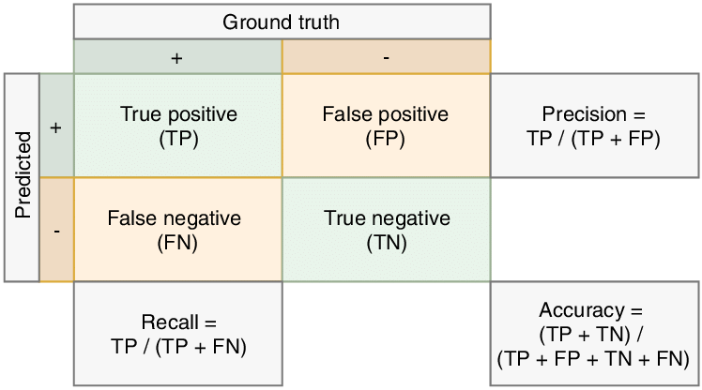

Figure 43: Confusion matrix

## Results:

The performance of all applied classifiers ensures the predictions' reliability and accuracy, as shown in tabel1. The highest accuracy is the RF model (accuracy 91%).

|  |  |  |  |  |  |  |  |
| --- | --- | --- | --- | --- | --- | --- | --- |
| Model | Accuracy (%) | Precision (%) | Recall (%) | F1-score (%) | Cross-Validation | | |
| cv=1 | cv=5 | cv=10 |
| K Nearest Neighbors | 65 | 78 | 68 | 89 | 68.7 | 86 | 75 |
| Decision tree | 90 | 90 | 90 | 90 | 87.5 | 73 | 85 |
| Random Forest | 87 | 88 | 86 | 87 | 93.7 | 86.6 | 92.79 |
| Naïve Bayes Classifier | 45.16 | n/a | n/a | n/a | n/a | 53.2 | 51.75 |
| Support Vetor Machine | n/a | n/a | n/a | n/a | 68.06 | 53 | 60 |

# Statistics For Data Analytics

## Descriptive statistics:

Descriptive statistics is a set of numerical and graphical techniques that describe, show, and summarize the basic features of the data set. It describes and analyzes specific populations, usually through samples. The descriptive statistics measures include:

Central measures:

Mean, median, and mode used to get the central tendency of our dataset to determine where the most typical value lies in our data set. The mode can be used with either numerical features (quantitative) or categorical(qualitative), while mean and median apply only to quantitative data.

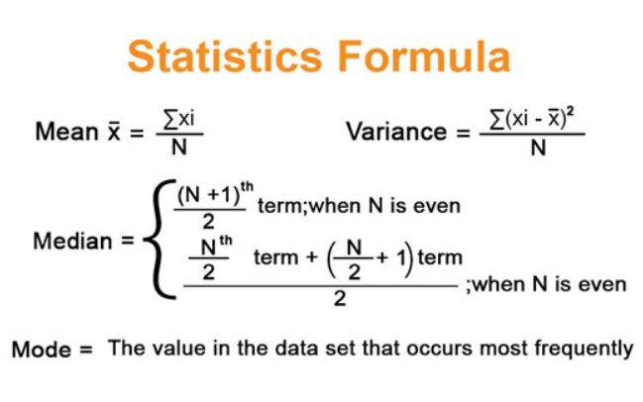

Variation measures:

Used to ​​determine the degree of homogeneity within the observations. In other words, the measure of the spread. Standard deviation is the most frequent measure of variation.

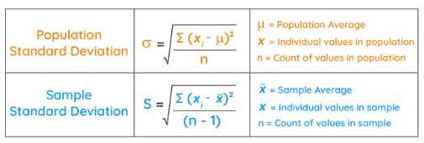

Figure [44]: gives the descriptive statistics for the numeric features in our data frame like Min, Max, Mean, Standard Deviation, and Median for the exported crops and livestock products in Ireland.

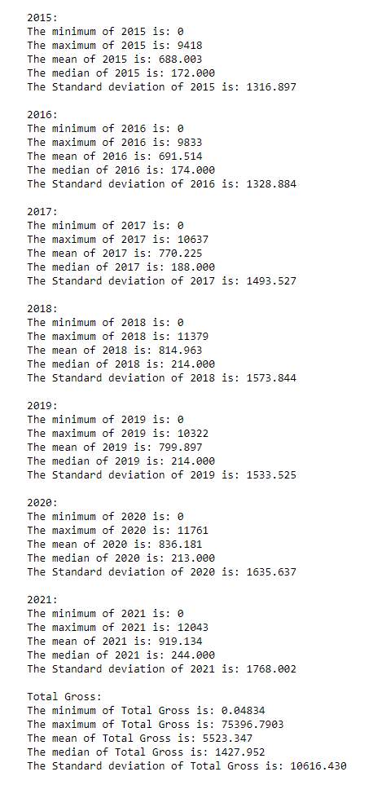

Figure 44:Descriptive statistics

**Calculate the yearly average value for crops and livestock product exports from Ireland:**

One Sample T-test**:** The one-sample t-test is a statistical hypothesis test used to test if the unknown population mean is different from a specific value.

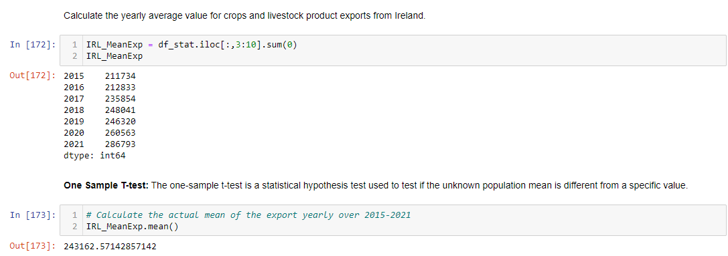

Figure 45:Yearly average value for exported products from Ireland

Figure [45] gives the yearly average for the crops and livestock products in Ireland. We need to set a hypothesized mean (the mean we'd like to test, or the mean we'd expect in the population). Suppose Population means µ, = 250000

Null Hypothesis: --> H0 = µ =25000

Alternative hypothesis: --> H1 ≠ µ,

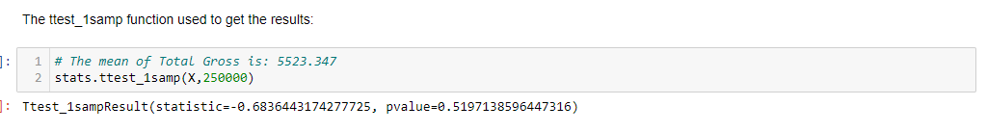

Let's describe the result, we got two values the first is the statistic=-0.68364431, it is the t-value and, the p-value which is 0.519, which is greater than 0.05, so we accept the null hypothesis and the alternative hypothesis is rejected. There is enough evidence to say that the average of exported crops is 250000 yearly.

If we want to test if the yearly export cost in $Million is less than €250000. We calculate the test at alpha = 5% significance level.

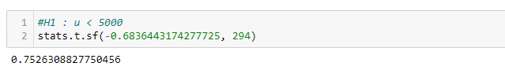

Again, the p-value = 0.75> 0.05. We accept the null hypothesis H0. We reject H0. Thus, there is enough evidence to say that the yearly export price in average greater than $ Million 250000.

## T-Test, two populations:

Suppose we want to test if there any difference in the average of the 'Total Gross' between export '' and Import crops and livestock products in Ireland at a 5% significant level.

We group the data according to import and export trade values:

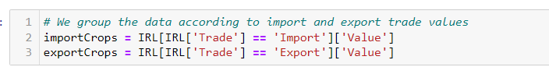

Hypothesis:

H0 => µ1 = µ2 (population mean of importCrops is equal to exportCrops)

HA => µ1 ≠µ2 (population mean of importCrops is different from exportCrops)

1. equal_var=True means that we take in consideration the equal population variances.

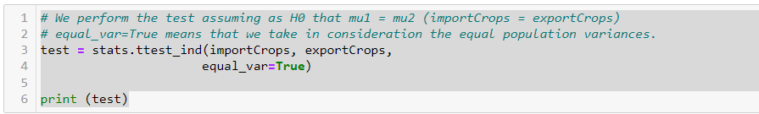

Ttest_indResult(statistic=-1.6120810710628641, pvalue=0.10702061485003227)

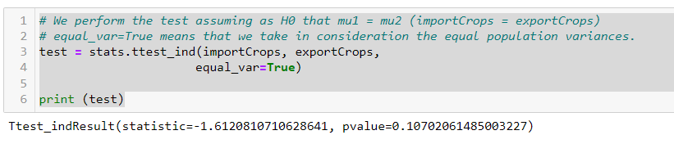

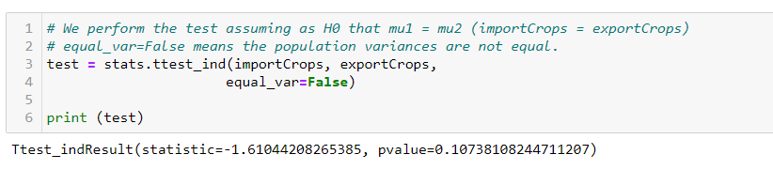

pvalue = 0.107 >0.05 We cannot reject the null hypothesis H0. There is enough evidence at 5% significance level to say that the population mean of importCrops is equal to exportCrops.

## ANOVA-oneway:

Check the normality of the import and export values to apply ‘ANOVA’

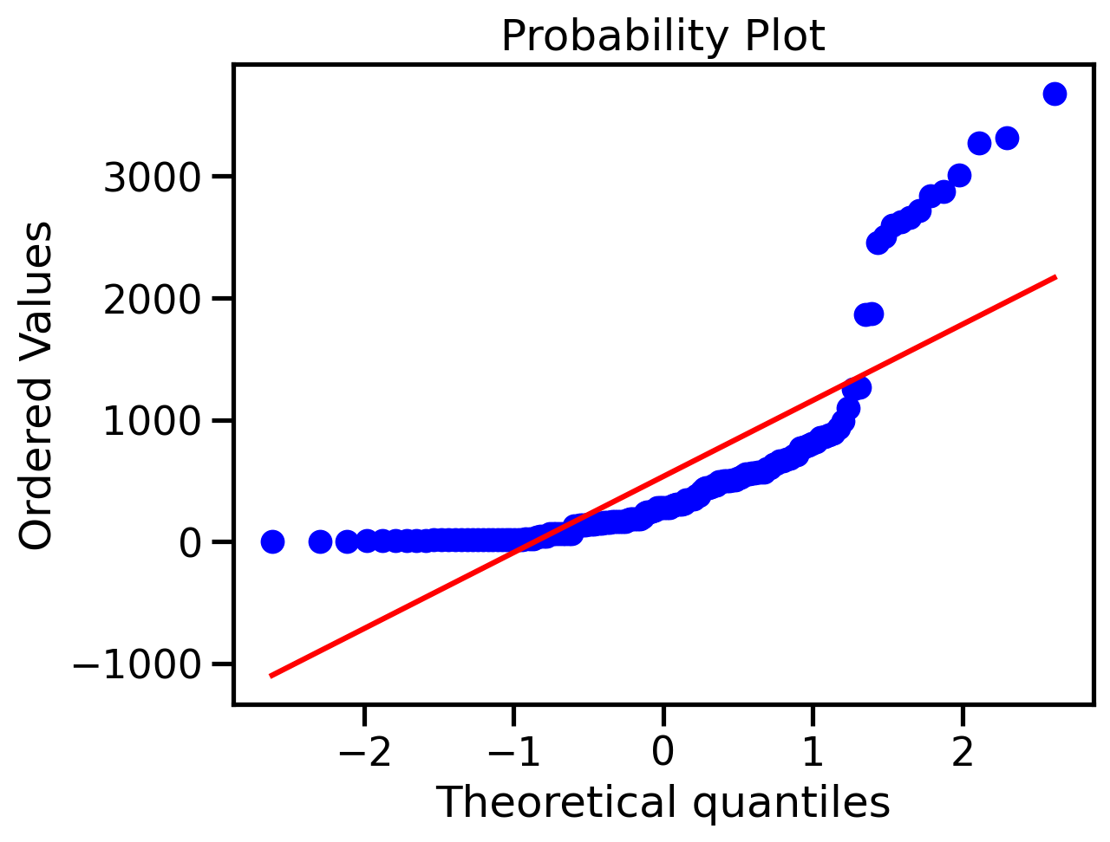

Figure 46probability plot for Import/Export in Ireland

Figure [46] shows that the data is not normally distributed

**Shapiro**

We apply the Shapiro wilk test to check if the sample data came from a normal distribution or not.

* H0 : The data normally distributed
* H1 :The data is not normally distributed

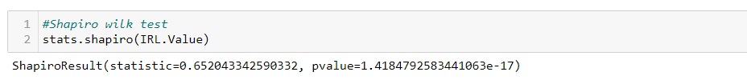

The p-value < 0.05, We reject the Null hypothesis. This enough evidence to say that the data is not normally distributed.

Please complete reading in the Jupiter file. Thanks

# References:

1. cmdlinetips (2021). How To Convert Two Columns from Pandas Dataframe to a Dictionary. [online] Python and R Tips. Available at: <https://cmdlinetips.com/2021/04/convert-two-column-values-from-pandas-dataframe-to-a-dictionary/>
2. Corporate Finance Institute. (n.d.). Imports and Exports. [online] Available at: <https://corporatefinanceinstitute.com/resources/economics/imports-and-exports/>.
3. GeeksforGeeks. (2018). Reset Index in Pandas Dataframe. [online] Available at: <https://www.geeksforgeeks.org/reset-index-in-pandas-dataframe/> [Accessed 26 Dec. 2022].
4. GeeksforGeeks. (2020). How to Add a Y-Axis Label to the Secondary Y-Axis in Matplotlib? [online] Available at: <https://www.geeksforgeeks.org/how-to-add-a-y-axis-label-to-the-secondary-y-axis-in-matplotlib/>
5. kaggle.com. (n.d.). Analysis on Indian Import Export. [online] Available at: <https://www.kaggle.com/code/shubhamsinghgharsele/analysis-on-indian-import-export>.
6. kaggle.com. (n.d.). Crop Yield Prediction. [online] Available at: <https://www.kaggle.com/code/aviraljain58/crop-yield-prediction>
7. pandas.pydata.org. (n.d.). pandas.DataFrame.describe — pandas 1.3.4 documentation. [online] Available at: <https://pandas.pydata.org/docs/reference/api/pandas.DataFrame.describe.html>.
8. pandas.pydata.org. (n.d.). pandas.DataFrame.pivot — pandas 1.3.5 documentation. [online] Available at: <https://pandas.pydata.org/docs/reference/api/pandas.DataFrame.pivot.html>.
9. pandas.pydata.org. (n.d.). pandas.DataFrame.shape — pandas 1.2.1 documentation. [online] Available at: <https://pandas.pydata.org/pandas-docs/stable/reference/api/pandas.DataFrame.shape.html>.
10. panel.holoviz.org. (n.d.). IntSlider — Panel v0.14.2. [online] Available at: <https://panel.holoviz.org/reference/widgets/IntSlider.html>.
11. panel.holoviz.org. (n.d.). Overview — Panel v0.14.1. [online] Available at: <https://panel.holoviz.org/>
12. panel.holoviz.org. (n.d.). RadioButtonGroup — Panel v0.14.2. [online] Available at: <https://panel.holoviz.org/reference/widgets/RadioButtonGroup.html>
13. plotly.com. (n.d.). Filled. [online] Available at: <https://plotly.com/python/filled-area-plots/>.
14. Schloss, K.B., Gramazio, C.C., Silverman, A.T., Parker, M.L. and Wang, A.S. (2019). Mapping Color to Meaning in Colormap Data Visualizations. IEEE Transactions on Visualization and Computer Graphics, 25(1), pp.810–819. <doi:10.1109/tvcg.2018.2865147>.
15. Scikit-learn.org. (2019). sklearn.preprocessing.OneHotEncoder — scikit-learn 0.22 documentation. [online] Available at: <https://scikit-learn.org/stable/modules/generated/sklearn.preprocessing.OneHotEncoder.html>.
16. scikit-learn.org. (n.d.). 1.9. Naive Bayes — scikit-learn 0.24.2 documentation. [online] Available at: <http://scikit-learn.org/stable/modules/naive_bayes.html>.
17. Simplilearn.com. (2021). Comments in Python: Why are They Important And How to Use Them. [online] Available at: [https://www.simplilearn.com/tutorials/python-tutorial/comments-in-python#](https://www.simplilearn.com/tutorials/python-tutorial/comments-in-python):~:text=Python%20provides%20an%20in%2Dbuilt [Accessed 28 Dec. 2022].
18. Srinidhi, S. (2020). Label Encoder vs. One Hot Encoder in Machine Learning. [online] Medium. Available at: <https://contactsunny.medium.com/label-encoder-vs-one-hot-encoder-in-machine-learning-3fc273365621>.
19. Stack Overflow. (n.d.). pandas - Matplotlib - Adding value labels to bar graph. [online] Available at: <https://stackoverflow.com/questions/70235487/matplotlib-adding-value-labels-to-bar-graph>
20. Stack Overflow. (n.d.). python - How to display data values in stacked horizontal bar chart in Matplotlib. [online] Available at: <https://stackoverflow.com/questions/54162981/how-to-display-data-values-in-stacked-horizontal-bar-chart-in-matplotlib> .
21. Stack Overflow. (n.d.). python - How to include an image in a Jupyter Lab notebook. [online] Available at: <https://stackoverflow.com/questions/61305845/how-to-include-an-image-in-a-jupyter-lab-notebook> [Accessed 24 Dec. 2022].
22. Stack Overflow. (n.d.). python - Pandas: Bar-Plot with two bars and two y-axis. [online] Available at: <https://stackoverflow.com/questions/24183101/pandas-bar-plot-with-two-bars-and-two-y-axis> [Accessed 6 Jan. 2023].
23. Stack Overflow. (n.d.). python - what is matplotlib’s retina display mode? [online] Available at: <https://stackoverflow.com/questions/54312924/what-is-matplotlibs-retina-display-mode> [Accessed 24 Dec. 2022].
24. Stack Overflow. (n.d.). python del vs pandas drop. [online] Available at: [https://stackoverflow.com/questions/47426089/python-del-vs-pandas-drop#](https://stackoverflow.com/questions/47426089/python-del-vs-pandas-drop):~:text= drop%20operates%20on%20both%20columns [Accessed 16 Dec. 2022]
25. Szabo, B. (2020). How to Create a Seaborn Correlation Heatmap in Python? [online] Medium. Available at: <https://medium.com/@szabo.bibor/how-to-create-a-seaborn-correlation-heatmap-in-python-834c0686b88e>
26. Yi, M. (n.d.). How to Choose Colors for Data Visualizations. [online] Chartio. Available at: <https://chartio.com/learn/charts/how-to-choose-colors-data-visualization/>.